Important for User
Shortcut Keys map | Ctrl + Alt + ? Puts map of shortcut keys on your screen
Safe eject a jump drive | Press “Shift+Alt+m” to launch File Manager. Click the triangle to eject USB jump drive.
Right Click | Use 2 fingers on touch pad, opens right click options box.
Missing Keys
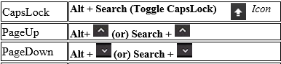 | 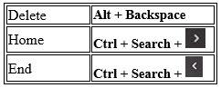
Page Shortcuts Text Editing
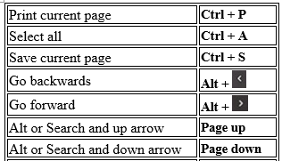  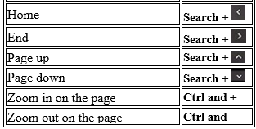 | Select All Ctrl + A  Copy Ctrl + C  Paste Ctrl + V  Paste (plain text) Ctrl + Shift + V  Cut Ctrl + X  Undo Ctrl + Z  Redo Ctrl + Shift + Z  Delete Search + backspace  Escape 1st Key (at top)  Insert Search +  Pring Ctrl + P  Save Ctrl + S  Top of page  Bottom of page
Managing Web Pages
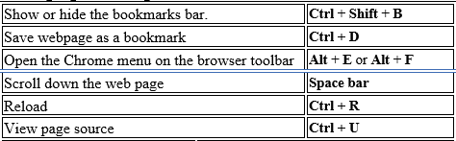
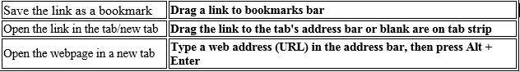
Managing the Screen
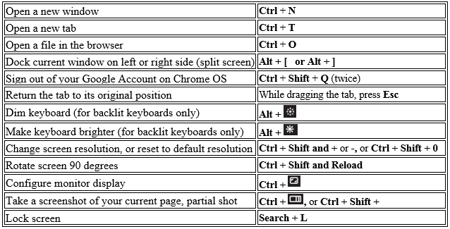
Managing the Device
Open the Files app | Alt + Shift + M
Open the Downloads page | Ctrl + J
Open the Task Manager | Search + Esc
Open the status area | Alt + Shift + S
See your notifications | Alt + Shift + N
Open or hide the list of available keyboard shortcuts | Ctrl + Alt + /
Get help with your Chromebook | Ctrl + ?
Open right-click menus for highlighted items | Shift + Search + Volume Up
Full Screen | 5th Key
Switch between open windows | 6th Key
Increase & Reduce brightness | +Alt
Power On and Off, Lock Screen | 12th Key
Function keys F1 through F12 | Search + 1 or Search + =
Switch between the keyboard languages you've set | Ctrl + Shift + Space, or Ctrl + Space

