MRS. Christian’s

Kindergarten Schedule

7:55-8:15 Calendar

8:15-9:40 ELAR, Guided Reading & Centers

9:40-10:10 Recess

10:10-10:55 Phonics & Handwriting

10:55-11:25 Lunch

11:25-12:00 Math

12:00-1:00 Elective & PE

1:00-2:10 Nap/ RTi

2:10-2:30 Recess

2:30-3:00 Writing & Snack

3:00-3:30 Science & Social Studies

3:30-3:45 Pack Up & Dismissal

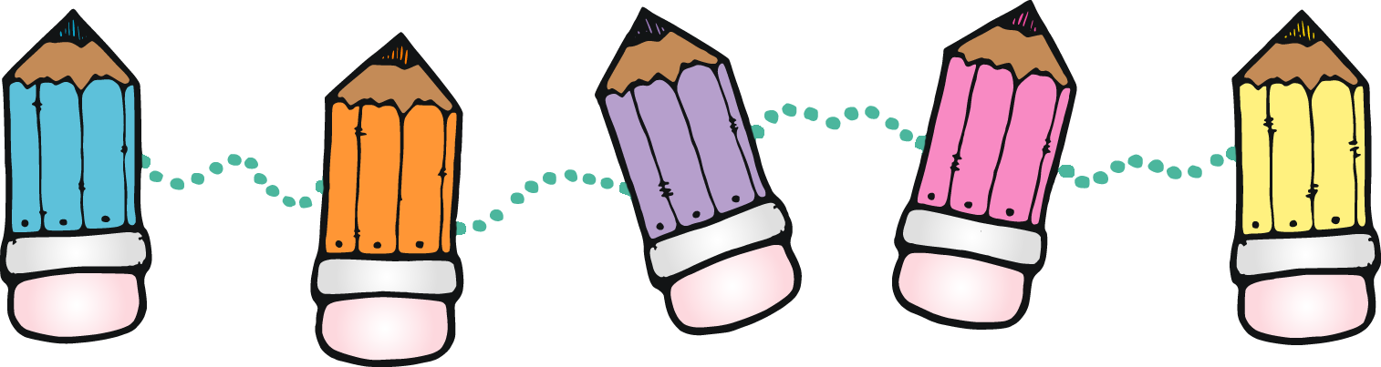

Ms. Dunnam’s

Kindergarten Schedule

7:55-8:15 Calendar

8:15-9:00 fundations & Read Aloud

9:009:40 Guided Reading & Centers

9:40-10:10 Recess

10:10-10:55 MATH

10:55-11:25 Lunch

11:25-12:00 Writing

12:00-1:00 Elective & PE

1:00-2:10 Nap/ RTi

2:10-2:30 Recess

2:30-3:30 Science & Social Studies

3:30-3:45 Pack Up & Dismissal



Kindergarten Expectations

Know letter names, upper and lowercase

Form letters correctly

Know letter sounds

Know 35 or more sight words

Reading Level: C or higher (Guided Reading)

Be able to use reading strategies taught

Know word families (chunks) and make words with those

Spelling tests in the Spring semester will cover 30 words over 10 weeks with punctuation

Rhyme: be able to pick out 2 words that rhyme and hear a rhyme in a passage that is read

Understand concepts of print

Front to back

Left to Right

Top to Bottom

Spaces in between words

Be able to use invented spelling

Know colors

Know color words

Know months of the years

Know days of the week

Know words that start with each letter of the alphabet

Know beginning and ending sounds in words

Know 2D & 3D shapes

Count to 100 by 1s, 5s, and 10s

Identify numbers 0-30

One to one counting

Know addition facts to 10

Read number words

Know directional words

Before and after

Above and below

Addition

Subtraction

Recognize and know the worth of money (penny, nickel, dime, quarter)

Comparing measurements

Hat Policy

Students will not be allowed to wear hats to school unless it is specific to a dress up day.

Behavior Expectations

Each student will use a color system to help with their behavior. We begin each day with a green card. If your student still has a green card at the end of the day, you will know that he/she had a great day! If your student does not obey our class rules, I will change the color cards, see what happens below. However, if I see your student do something really good or even awesome the color card will get changed to purple or pink. Below is our behavior color chart:

Pink- Your student did something extraordinary!

Purple- Your student is following our social contract and has been caught doing something good.

Green- Your student had a great day!

Orange- I gave your student another warning and then I will go through these questions with your student:

What are you doing?

What are you supposed to be doing?

Are you doing it?

What are you going to do about it?

What is going to happen if you break our social contract again?

If this is a repeat offense your child will get a logical consequence and a note home.

Red- If a red card is given that means the appropriate action was not taken and the student will visit with the principal and have logical consequences given.

Birthday Party Guidelines

We do celebrate birthdays! Please feel free to send cupcakes or cookies to celebrate your child’s birthday. You can send enough for the entire kindergarten or enough for your child’s classroom. We usually celebrate at snack time, which is at 2:30 in the afternoon. You can bring the food item to the office and they will get it to us!

Homework

The first semester homework will be practicing their name writing. The second semester we will start spelling so your child will have homework more frequently. All homework will not take more than 5-10 minutes.

Reward Center

Reward Center will look different this year compared to previous years. Students will earn time to celebrate their good behavior with a party at the end of each report card period. Students must not receive more than 7 color changes throughout the report card period to receive the award.

Retention Policy

**Kindergarten:**

In addition to the factors in law that must be considered for promotion mastery shall be determined as follows:

* Individual progress as measured by the state standards and assessment test results (e.g., TPRI, BAS, TEMI).
* Performance in meeting grade level expectations in reading and math
* Attendance [see FEC].
* Maturity (academic, social, emotional, and physical)
* Teacher, principal, RtI committee, and parent/legal guardian observations and recommendations
* A student shall be retained if the student does not meet grade-level expectations in both reading and math

The principal is authorized to review the criteria in this policy in determining whether a student shall be retained. A parent may appeal the decision of the principal in accordance with FNG (LOCAL).   
  
We work hard every day to ensure our students are learning. When students are struggling and need interventions, we communicate that with you. If students continue to struggle and don’t show appropriate mastery with interventions, we will communicate this with you. Retention is only considered when we feel like it is best option for your student.

Movie Permission

Dear parents and families,

There are some instances where we may watch a movie in class. These instances include reward days, party days, field trip days, holidays, book comparison, etc.

Below is a list of movies we may watch on these days and their ratings. For your child to participate in the movie days, we will need a signed permission slip allowing your child to participate. If you do not give your child permission, another activity will be provided for your child during the movie.

Movies:

|  |  |  |  |
| --- | --- | --- | --- |
| Lorax (G) | Monsters, Inc. (G) | A Bug’s Life (G) | The Jungle Book (G) |
| Wall-E (G) | Horton Hears a Who (G) | Lady & The Tramp (G) | The Little Rascals (PG) |
| Toy Story (G) | Babe (G) | Peter Rabbit (G) | Rio (G) |
| Ratatouille (G) | Cars (G) | Monster’s University (G) | Rio 2 (G) |
| Charlotte’s Web (G) | The Lion King (G) | Finding Dory (G) | Charlie Brown (G) |
| Polar Express (G) | Willy Wonka & the Chocolate Factory (original) (G) | Grinch (G) | The Little Engine that Could (G) |
| Spookley the Square Pumpkin (G) | Finding Nemo (G) | Frozen (G) | Dr. Seuss (TV-Y) |
| Elf on the Shelf (TV-Y) | Llama Lama (TV-Y) | PBS Kids | Madagascar (PG) |
| Encanto (PG) | Aladdin (G) | Hop (PG) |  |

If for some reason we decide on a movie not on the list, you will receive a notification via Class Dojo a day before.

-Kindergarten Teachers-

-----------------------------------------------------------------------------------

Student First & Last Name ____________________________________________________________

Date __________________ Parent Signature ______________________________________________